**Assignment 3**

Web Analytics ISGB/BYGB 7978

Name_________________ ID_________________

1. Any late submissions will have points deducted as follows: 1 day late: -15%, 2 days late: -30%; not accepted for grading if submitted after 3 or more days. Any such assignments will receive score of zero.
2. Late submission due to special occasions can be discussed separately with the instructor.
3. Extra point is not required but will give you extra credit if done right.

“Social media listening” technique helps companies to analyze their new product launch response and benchmark against competitors. You will explore how Twitter can be used for social media listening in this homework.

1. Identify a focal product/service of interest. For example, iPhone 8. Identify 2-3 competitor’s products. (This can also be a Website, for example, Amazon vs. eBay and Target, or even celebrities.) Pick 3 product features of interest. For example, if you choose iPhone and Samsung, the comparison feature can be Price, Screen, Size.
2. Prepare a list of hash tags or relevant keywords that are relevant to your focal product and the competitors product. For example “#iPhone8”, “#iPhone8Plus”.
3. Use the TwitterAPI program introduced in class to crawl tweets for all products. You should get at least 100 tweets for each crawling. If you have multiple hashtags or if you crawl several times, you will get more than 100 tweets.
4. Process the crawled data and keep the following information in a csv file: user screen name, number of comments, location, Tweet text. Include his processed file as part of your assignment to be submitted.
5. Use a Word Cloud tool (such as <https://www.wordclouds.com/> or <http://www.wordle.net/create>), paste the crawled Twitter content and generate 3 (or 4) Word Cloud for the focal product and the competitors. An example of a Word Cloud is shown below:

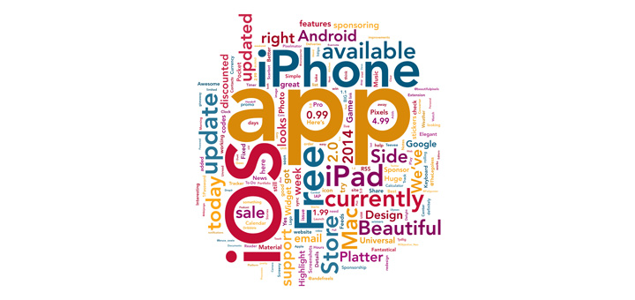

1. Observe the results and evaluate if the three product features you picked appeared in the Word Cloud. Based on your observation, provide a comparison table of the focal product and its benchmarks.
2. Bonus point: Try to use Tweepy (available in the lab tutorial) to perform the task. How many Tweets can you get?